**1.**

using System;

using System.Windows.Forms;

namespace GooseEggCalculator

{

/* A program to sum the number of eggs produced by 4 geese then display

* the total, number of dozens, and the number that would not fit in a

* dozen.

*/

// Written By: Sam Graham, Tampa, FL, USA

// Written On: 2/2/2019

public partial class frmGooseEggCalculator : Form

{

public frmGooseEggCalculator()

{

InitializeComponent();

}

private void btnCalculate_Click(object sender, EventArgs e)

{

int EGGS_IN_DOZEN = 12; // 12 eggs in a dozen, shouldn't change.

int totalEggs = Convert.ToInt32(txtGoose1.Text) +

Convert.ToInt32(txtGoose2.Text) +

Convert.ToInt32(txtGoose3.Text) +

Convert.ToInt32(txtGoose4.Text);

int numOfDozens = totalEggs / EGGS_IN_DOZEN;

int remainingEggs = totalEggs % EGGS_IN_DOZEN;

lblTotalEggs.Text = Convert.ToString(totalEggs);

lblDozens.Text = Convert.ToString(numOfDozens);

lblRemaindNotInDozen.Text = Convert.ToString(remainingEggs);

// all of these labels are initially not visible on the form.

lblTitleTotalEggs.Visible = true;

lblTotalEggs.Visible = true;

lblTitleDozens.Visible = true;

lblDozens.Visible = true;

lblTitleRemainderEggs.Visible = true;

lblRemaindNotInDozen.Visible = true;

}

}

}

**Output on next page:**

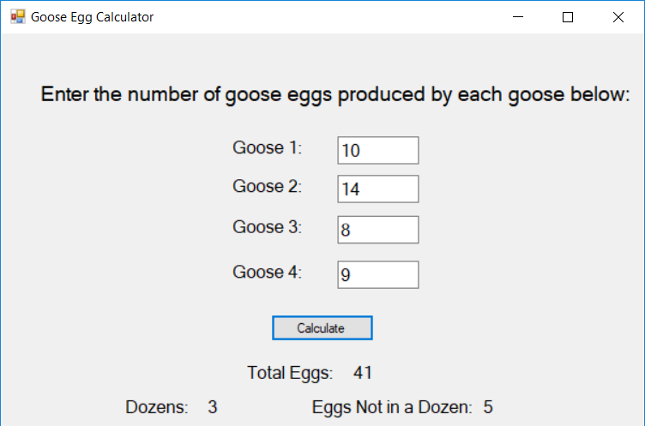

**2.**

using System;

using System.Windows.Forms;

namespace IGPAY

{

public partial class frmIGPAY : Form

{

/* A program to translat a word given by user into Pig Latin.

* Moving the first letter of the word to the end and adding

* "ay" is considered Pig Latin

*/

// Written By: Sam Graham, Tampa, FL, USA

// Written On: 2/2/2019

public frmIGPAY()

{

InitializeComponent();

}

private void btnConvert_Click(object sender, EventArgs e)

{

int stringLength = txtUserPhrase.Text.Length - 1;

String addingPigLatin = txtUserPhrase.Text.Substring(0, 1) + "ay";

String convertedString = txtUserPhrase.Text.Substring(1, stringLength) + addingPigLatin;

lblConvertedPhrase.Text = convertedString;

lblConvertedPhrase.Visible = true; // initially label is not visible.

}

}

}

**Output:**

